

TECHNICAL WRITING & PRESNTAION SKILLS

SPELLING,PUNCTUATION &

PARAGRAPH WRITING

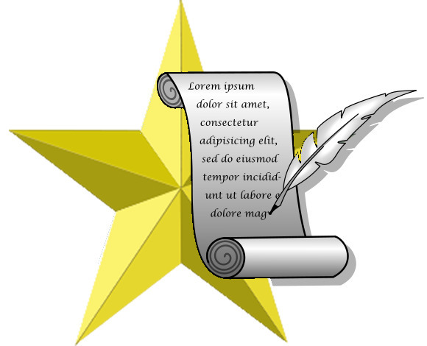

**ASADULLAH**

**D-10-IND-1354**