PRACTICAL 9

OBJECTIVE:

To study various computer controlled business functions.
Contents:
1) Purchase order receiving
2) Sales and marketing
3) Job costing
4) Bill of Material
5) Financial control
6) Inventory management

INTRODUCTION
Personal computers have become the most empowering tool we've ever created. They're tools of communication, they're tools of creativity, and they can be shaped by their user. - Bill Gates
Almost everyone is aware that Information Technology (IT) has played a very significant role in taking businesses to new heights. Before the advent of computers and relevant technology, businesses were totally done using manual resources. As a result, the time taken to complete a task was more, quality of work was not up to the mark, and the procedures also tended to be more complicated. However, as computers started to be used in businesses establishments, the processing of work got more stabilized. If you are a working professional, you surely might have easily known how much computer technologies are used in businesses. These technologies are used in almost all sectors such as accounts and payroll management, inventory management and control, shipping functions, data and database management, financial analysis, software development, security control and many other essential fields. The end result of use of computer in business is increased productivity and quality.
COMPUTER CONTROLLED BUSINESS FUNCTION
Following are only a few major fields in business where computing is used largely.
- SALES AND MARKETING:
Marketing is an organizational function and a set of processes for creating, communicating and delivering value to customer relationships in ways that benefit the organization and its stakeholders. The marketing challenge in the next decade will be to develop programs to utilize the computer to the department's maximum advantage. A major responsibility for providing the information from which decisions can be made on an economic and timely basis will fall upon the salesman. Marketing areas which could contribute to improving the profit picture through computerization include sales methods analysis, product quality analysis, product elimination, and customer elimination.
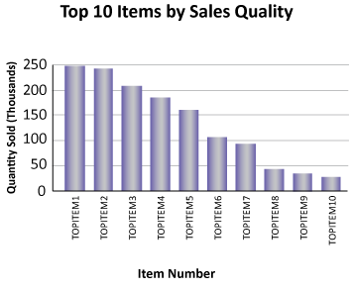
Role of Computers In Marketing
● Web based Promotion has become most efficient way of advertising and marketing due to potential to reach millions of customers all around the world.
● Market Research is the collection of data concerning the current sate of market, consumer preferences and competitors. Administering online surveys was one of the major tools under it.
● Distribution allows companies to distribute their products and services to remote users via the INTERNET, without need of physical office or retail storefront.
● Advertisement through other media can also be done through computers as they can be often used to design the layouts of the pages. Graphic Designers and media specialist use computers to edit their commercials.

INVENTRY CONTROL AND MANAGEMENT:
Computerization has revolutionized inventory management, as technologies ranging from automatic scanners to radio frequency identification chips now allow businesses to track their inventory from the moment a company buys it wholesale to the moment the products leave the building in the hands of a customer.

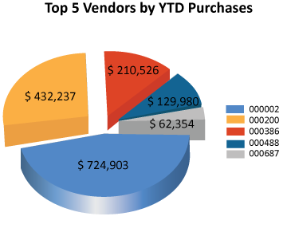
Receipt of Goods
A retail store or a central warehouse uses bar code or radio-frequency identification scanning at the point of receipt of goods. Scanning individual items or shipment pallets allows a company to itemize all shipments from the supplier, which can be compared against the purchase order for errors or losses in transit. When your business ships these goods out of the warehouse to their point of sale, a second scan can automatically tally the remaining stock in the warehouse, and send messages to the purchasing managers indicating that it is time to reorder.

Retail Turnover
Many businesses use similar scanning techniques at the point of checkout. As of 2010, bar code scanners are more popular than RFID for this purpose. Both will automatically enter the correct price at the register and prevent data entry errors. They also can create a perfect real-time record of how much stock remains on the shelves, how much is available in on-site storage, and whether a new shipment is necessary from the warehouse. Combine this information with warehousing data, and your business can create additional alerts to key management when a bottleneck occurs. For example, if a dozen retail stores anticipate needing restocking, but the warehouse does not have sufficient goods on hand, your business can place a rush order to fill the need.

Stock Management and Cost Reduction

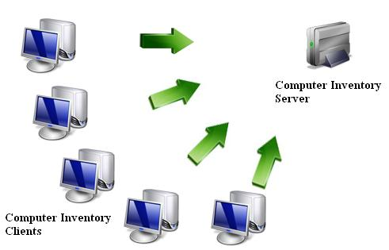
The process of moving goods through a company pipeline is always economically inefficient. The purchase of the goods represents an investment of company capital, which your business cannot recoup until you sell your inventory. Warehousing of goods before sale introduces the possibility of inventory shrinkage in value from theft, damage, deterioration or changes in customer taste. Moving goods from warehouses to the point of sale involves shipping costs, especially if the shipment is incorrect, or if the internal shipping process is inefficient. Computerization provides a real-time picture of this entire work flow process, and allows managers to reduce purchasing costs through minimizing inventory, increase the efficiency of internal shipping systems, and reduce the possibility of theft or damage by being able to track each item down to the individual staffer who takes responsibility for it.
- ACCOUNTS AND PAYROLL MANAGEMENT:
Accounting and payroll management is also believed to be an important part of the overall system in a company. Be it any kind of industry; computers are largely used for the purpose of managing accounts of administration, sales, purchases, invoices, and also payroll management, which includes recording financial details of employees. These are just some components of the accounts and payroll management system where computing is used.

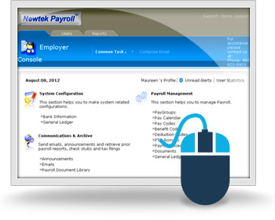
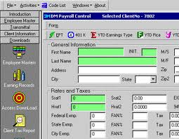

Report Generation

By keeping all your payroll accounting records in a computer, it’s easy for you to put reports together for the company and for your employees. For example, you can pull together analyses of how many hours are being worked, and at what rates of pay, by employees throughout the company, allowing you to tweak efficiency. At the end of the year, you can easily generate W-2 forms for your employees without having to do a lot of extra work.

Advantages
Instead of having to constantly battle with numbers, computerized payroll accounting only requires you to enter numbers correctly once. From there, the payroll program does any necessary mathematical equations for tasks like taking out taxes and other deductions. This allows less room for human error, and theoretically greater accuracy in your books. A computerized payroll accounting system also takes up less storage space than a lot of bulky binders or files. It’s also an easier solution to doing payroll if you have a habit of working remotely from outside the office.

Considerations
If you’ve been happy using another payroll accounting system and have a good system in place, learning a computerized payroll accounting system may take valuable time. It’s up to you whether you want to spend the time learning such a system. If you know you’ll be teaching others how to handle your company’s payroll accounting, a computerized system may be more forgiving. If you make a mistake, it’s easier to delete and retype something than it is to meticulously go through paper files to change every handwritten error

- FINANCIAL CONTROL:
The primary tools of financial control are budgets. A budget specifies the resources committed to a plan for a given project or time period. Fixed budgets are independent of the level of activity of the unit for which the budget is drawn up. Flexible budgets commit resources depending on the level of activity.
Spreadsheet programs are the main budgeting tools. Spreadsheets are the personal productivity tools in use today in budget preparation.
In the systems-theoretic view, budgets serve as the standard against which managers can compare the actual results by using information systems. Performance reports are used to monitor budgets of various managerial levels. A performance report states the actual financial results achieved by the unit and compares them with the planned results.
Along with budgets and performance reports, financial control employs a number of financial ratios indicating the performance of the business unit. A widely employed financial ratio is return on investment (ROI). ROS shows how well a business unit uses its resources. Its value is obtained by dividing the earnings of the business unit by its total assets.
Funds Management
Financial information systems help to manage the organization's liquid assets, such as cash or securities, for high yields with the lowest degree of loss risk. Some firms deploy computerized systems to manage their securities portfolios and automatically generate buy or sell orders.
Internal Auditing
The audit function provides an independent appraisal of an organization's accounting, financial, and operational procedures and information. All large firms haveinternal auditors, answerable only to the audit committee of the board of directors. The staff of the chief financial officer of the company performs financial and operational audits. During a financial audit, an appraisal is made of the reliability and integrity of the company's financial information and of the means used to process it. An operational audit is an appraisal of how well management utilizes company resources and how well corporate plans are being carried out.

- DATABASE MANAGEMENT:
Database management is associated with filing and recording, managing, and retrieval of data whenever required. For smooth running of businesses, it is very important that they have all procedures and details stored. This storage of data is done with the help of large databases and servers which have to be maintained on a regular basis. These information databases and servers are controlled by computers by appropriate authorities in a company.
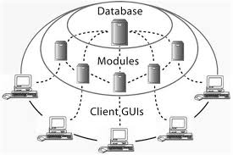

- BILL OF MATERIALS:
Bill of material records (BOM), contains information on every item or assembly required to produce end items. Information on each item, such as part number, description, quantity per assembly, next higher assembly, lead times, and quantity per end item, must be available. Most small and mid-size businesses (SMBs) start with their product bill of materials (BOM) in Excel spreadsheets — why should you be any different? Excel is a well-known, flexible application that everyone has — It is easy and it is essentially free. Small companies can make it through the first release of a new product just fine using Excel to manage product data.
But when companies release more products, grow internally or add more manufacturing and outsourcing partners, the act of managing an Excel bill of materials becomes much bigger and more complex. In this case the companies usually go for an ERP system which allows them to easily create and maintain a detailed bill of the components and miscellaneous charges that make up your finished items and subassembly components.

