Practical No.4

Objective:
Manual Part Programming on CNC Milling,
i. Introduction to G-Codes & M-Codes
ii. Formulation of part programming in cimco. Use ISO milling operations, and write your roll no. as 1333

Tools & Equipment:
Computer with CIMCO Installed.

Theory: Introducton to G Codes & M Codes
G-code is the common name for the most widely used numerical control (NC) programming language, which has many implementations. Used mainly in automation, it is part of computer-aided engineering. G-code is sometimes called G programming language.
In fundamental terms, G-code is a language in which people tell computerized machine tools what to make and how to make it. The "how" is defined by instructions on where to move to, how fast to move, and through what path to move. The most common situation is that, within a machine tool, a cutting tool is moved according to these instructions through a tool path, cutting away excess material to leave only the finished work piece. But the same concept also extends to noncutting tools, such as forming or burnishing tools; to additive methods; and to measuring probes that validate the results.
Codes that begin with M are called miscellaneous words. They control machine auxiliary options like coolant and spindle direction. Only one M-code can appear in each block of code.
LIST of Codes and their function:

G00 Rapid move G0 X# Y# Z# up to eight axes or G0 Z# X#
G01 Feed Rate move G1 X# Y# Z# up to eight axes or G1 Z# X#
G02 Clockwise move
G03 Counter Clockwise move
G04 Dwell time G04 L#
G08 Spline Smoothing On
G09 Exact stop check, Spline Smoothing Off
G10 A linear feedrate controlled move with a decelerated stop
G11 Controlled Decel stop
G17 XY PLANE
G18 XZ PLANE
G19 YZ PLANE
G28 Return to clearance plane
G33 Threading (Lathe)
G35 Bypass error checking on next line
G40 Tool compensation off
G41 Tool compensation to the left
G42 Tool compensation to the right
G43 Tool length compensation - negative direction
G44 Tool length compensation - positive direction
G49 Tool length compensation cancelled
G53 Cancel work coordinate offsets
G54-G59 Work coordinate offsets 1 through 6
G61 Spline contouring with buffering mode off
G64 Spline contouring with buffering mode on
G65 Mill out rectangular pocket
G66 Mill out circular pocket
G67 Flycut
G68 Mill out rectangular pocket with radius corners
G70 Inch mode
G71 Millimeter mode
G74 Peck drilling (Lathe) G83 Z# X# R#
G81 Drill cycle G81 X# Y# Z# R#
G82 Dwell cycle G82 X# Y# Z# R#
G83 Peck cycle G83 X# Y# Z# R#
G84 Tapping cycle G84 X# Y# Z# R# C#
G85 Boring cycle 1 G85 X# Y# Z# R#
G86 Boring cycle 2 G86 X# Y# Z# R#
G88 Boring cycle 3 G88 X# Y# Z# R#
G89 Boring cycle 4 G89 X# Y# Z# R#
G90 Absolute mode
G91 Incremental mode
G92 Home coordinate reset G92 X# Y# Z#
G94 IPM mode (Lathe) default
G95 IPR mode (Lathe)
G96 Constant Surface Feed On (Lathe)
G97 Constant Surface Feed Off (Lathe)
G110 Lathe Groove Face
G111 Lathe Groove OD
G112 Lathe Groove ID
G113 Lathe Thread OD
G114 Lathe Thread ID
G115 Lathe Face Rough
G116 Lathe Turn Rough
G120 Mill Outside Square
G121 Mill Outside Circle or Island
G122 Mill Out Counter Bore
G123 Mill Outside Ellipse pocket
G124 Mill Inside Ellipse pocket
G125 Mill Outside Slot
G126 Mill Inside Slot pocket
G130 3D tool compensation with gouge protection
G131 3D offset parallel to 3D profile
G132 3D tool compensation with gouge protection in the Z axis only
G135 5 axis tool compensation with gouge protection
G136 Included angle limit for gouge protection. G136 L#
G140 3D part rotation and plane tilting G140 U# V# W# R#
G141 Scale factor for the X axis only. G141 L#
G142 Scale factor for the Y axis only. G142 L#
G143 Scale factor for the Z axis only. G143 L#
G160 Mill 3D Cylinder
G162 Mill 3D Sphere
G163 Mill 3D Ramped Plane
G170 Set soft limits and crash fixture/chuck barriers to defaults
G171 Set backward crash fixture/chuck barriers G171 U# V# W#
G172 Set forward crash fixture/chuck barriers G172 U# V# W#
G181 Bolt Hole Drill
G182 Bolt Hole Dwell
G183 Bolt Hole Peck
G184 Bolt Hole TapG185 Bolt Hole Bore
Common M Codes
Default M codes used on most machines types. User customizable M codes will change based on application and user definition.
M02 End of Program
M03 Spindle On Clockwise, Laser, Flame, Power ON
M04 Spindle On Counter Clockwise
M05 Spindle Stop, Laser, Flame, Power OFF
M06 Tool Change
M08 Coolant On
M09 Coolant Off
M10 Reserved for tool height offset
M13 Spindle On, Coolant On
M30 End of Program when macros are used
M91 Readout Display Incremental
M92 Readout Display Absolute
M97 Go to or jump to line number
M98 Jump to macro or subroutine
M99 Return from macro or subroutine
M100 Machine Zero Reset
M199 Mid program start

B. Using ISO Milling, simulation of tool path like my roll number “1333”
Step 1. Start CIMCO EDIT Software
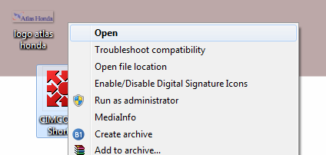
Step 2. Click New in the top end corner below file.
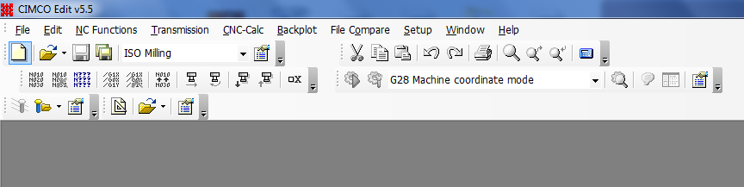
Step 3. Click Back plot window to see a real time effect of code we have entered.
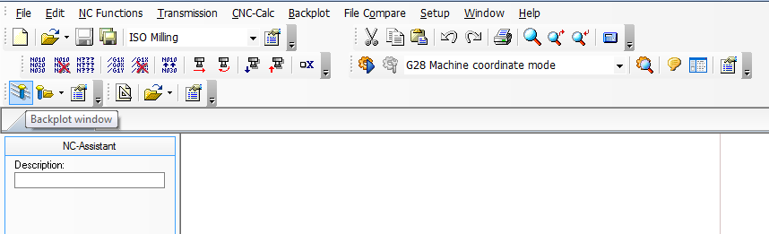

Step 4. Enter the basic machine codes and start defining the geometry to be created by milling operation. The code shows that the tool is ready.
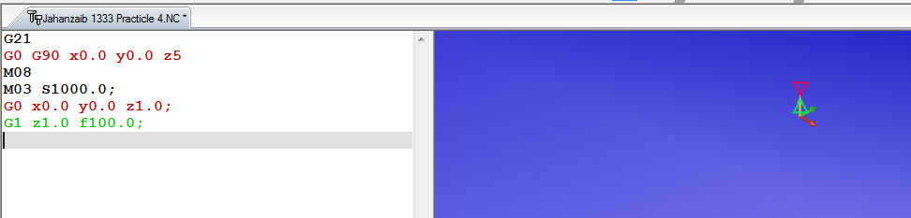
Step 5. Enter the code for 1. After entering the code we see that the spindle & coolant are turned off while the spindle is ready to move for next digit ‘3’.
Step 6. Move the spindle at height Z=1 to next point as follows:
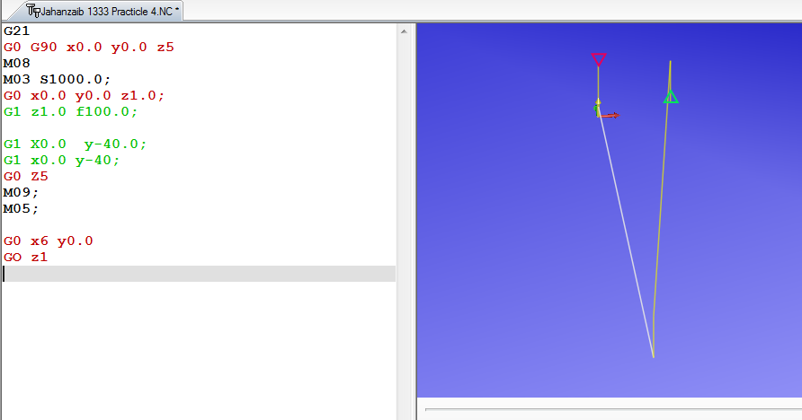
Step 7. Define geometry for digit 3 in absolute positioning.
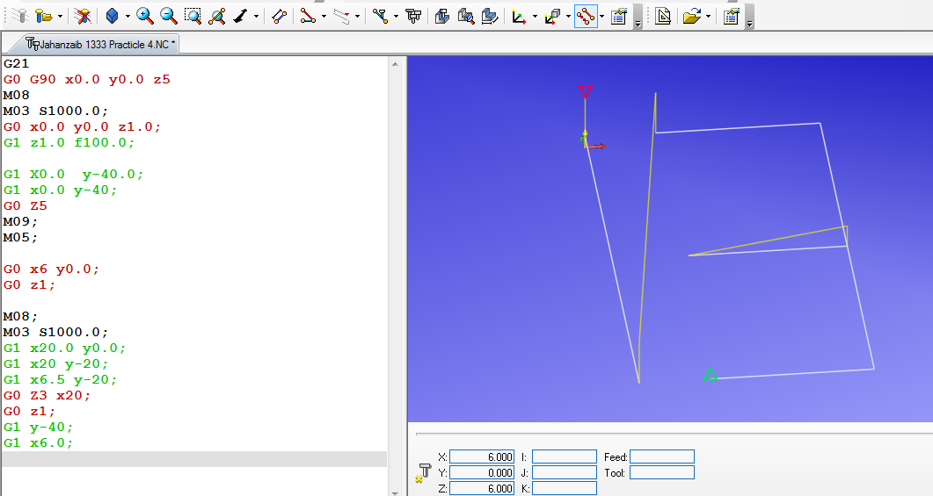
Step 8. Enter code G91 (All the codes are incremental now) and define geometry for next digit i.e 3.
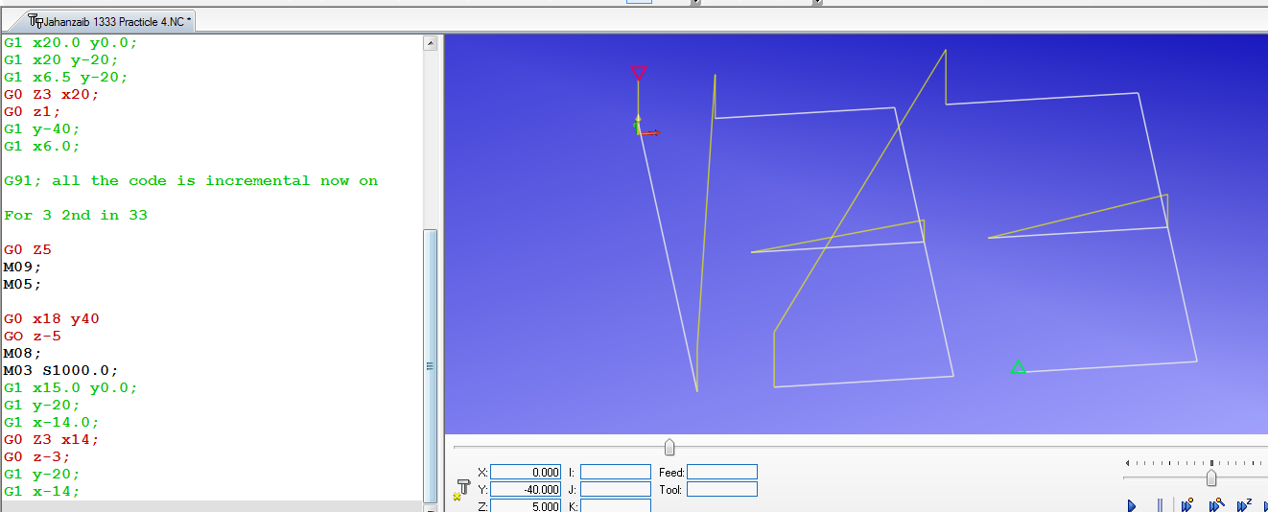
Step 9. Copy the same incremental code as in step 8 along with machine codes to generate the similar tool path as we have the same digit, i.e 3.
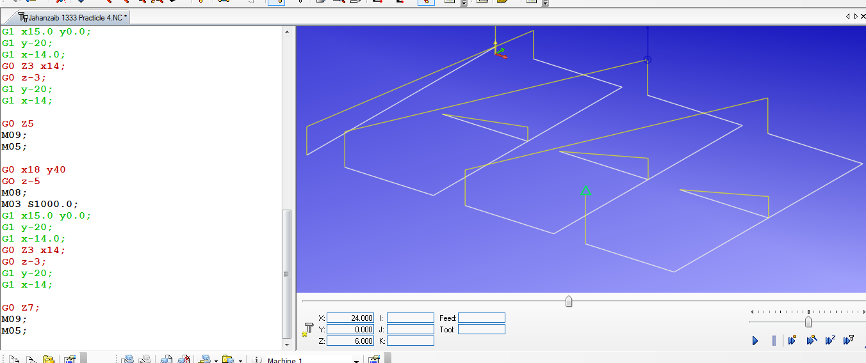
Step 10. Hide rapid moves of spindle.
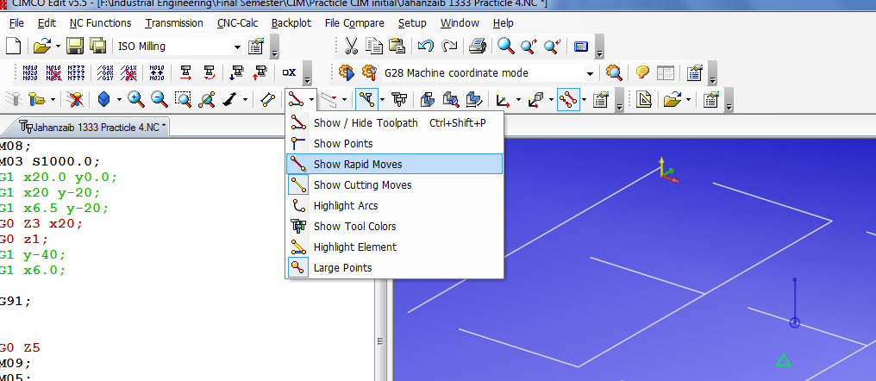
11. The formulation of Code is complete. Run the Simulation
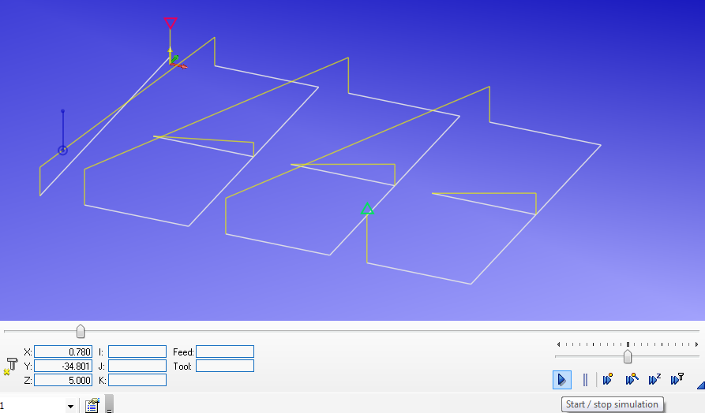

Results:
- Following Geometry is generated with the code we made:
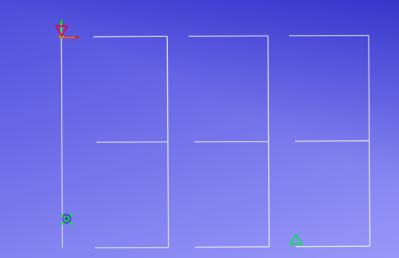

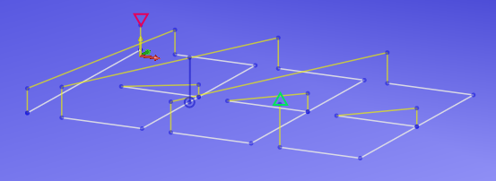

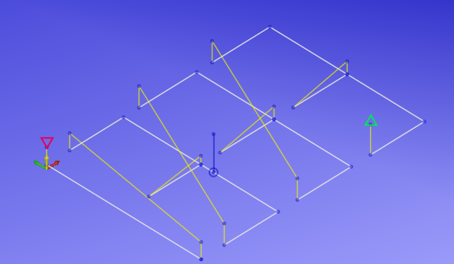
Result 2. The simulation was carried out successfully.
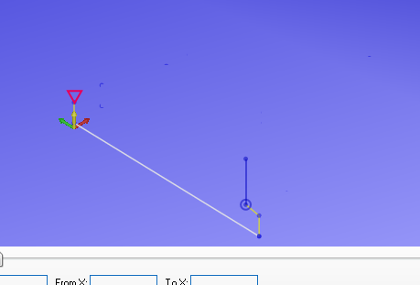
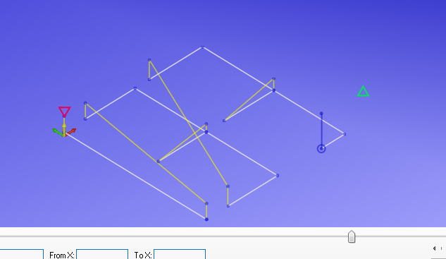
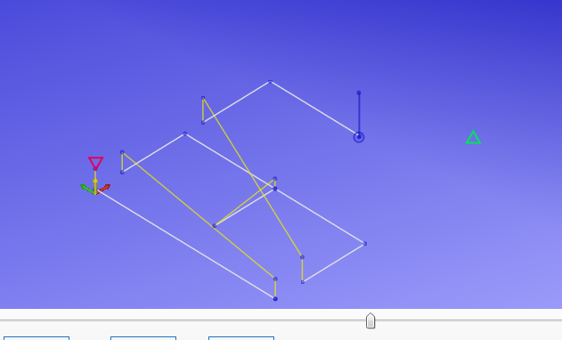

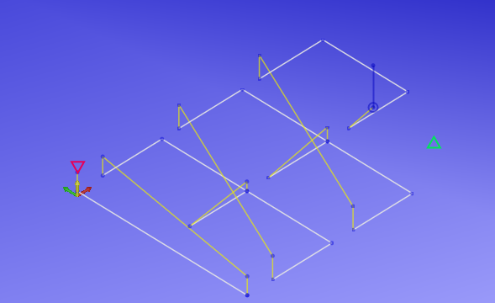

Result 3.
Following Code was successfully simulated for defining the geometry of the Roll Number 1333.
Codes for writing 1333

Start Here
G21
G0 G90 x0.0 y0.0 z5
M08
M03 S1000.0;
G0 x0.0 y0.0 z1.0;
G1 z1.0 f100.0;
G1 X0.0 y-40.0;
G1 x0.0 y-40; G0;
G0 Z5
M09;
M05;
For 3

G0 x6 y0.0
GO z1
M08;
M03 S1000.0;
G1 x20.0 y0.0;
G1 x20 y-20;
G1 x6.5 y-20;
G0 Z3 x20;
G0 z1;
G1 y-40;
G1 x6.0;
G91; all the code is incremental now on

For 3 2nd in 33
G0 Z5
M09;
M05;
G0 x18 y40
GO z-5
M08;
M03 S1000.0;
G1 x15.0 y0.0;
G1 y-20;
G1 x-14.0;
G0 Z3 x14;
G0 z-3;
G1 y-20;
G1 x-14;

For 3rd 3 in 1333
G0 Z5
M09;
M05;
G0 x18 y40
GO z-5
M08;
M03 S1000.0;
G1 x15.0 y0.0;
G1 y-20;
G1 x-14.0;
G0 Z3 x14;
G0 z-3;
G1 y-20;
G1 x-14;

G0 Z7;
M09;
M05;

